**FLOOD MONITORING AND EARLY WARNING**

**INTRODUCTION**

**The primary effects of flooding include loss of life and damage to buildings and other structures, including bridges, sewerage systems, roadways, and canals. The economic impacts caused by flooding can be severe.**

**Flood monitoring and early warning systems typically involve the following components:**

1.Data Collection: Collect data from various sources such as weather stations, river gauges, rainfall sensors, and remote sensing satellites. This data includes information on rainfall, river levels, soil moisture, and weather forecasts.

1. Data Analysis:Use advanced algorithms and models to analyze the collected data to identify potential flood risks. This can involve assessing rainfall patterns, river levels, and soil saturation levels.
2. Warning Generation:When the analysis indicates a potential flood risk, generate warnings. These warnings can be in the form of alerts to government agencies, emergency services, and the public.
3. Communication:Ensure that warnings reach the appropriate authorities and communities in a timely manner. This may involve using various communication channels such as SMS, mobile apps, sirens, and social media.
4. Evacuation Planning:Develop evacuation plans and routes in advance so that people can safely move to higher ground if necessary.
5. Public Awareness:Educate the public about flood risks, the importance of heeding warnings, and how to prepare for floods.
6. Monitoring and Feedback: Continuously monitor the situation and update warnings as needed based on real-time data. Also, gather feedback to improve the system’s accuracy and effectiveness.
7. Infrastructure Improvement: Invest in infrastructure like levees, flood barriers, and drainage systems to mitigate flood risks.
8. Cross-Agency Collaboration:Collaboration between meteorological agencies, environmental agencies, emergency services, and local governments is crucial for an effective flood monitoring and early warning system
9. Research and Development:Invest in research to improve the accuracy and lead time of flood predictions, as well as the reliability of warning systems.

Implementing a comprehensive flood monitoring and early warning system involves a combination of technology, infrastructure, and public education to minimize the impact of floods on communities

**The composition of the flood warning system**

The warning system includes:

* 1.**Wireless sensor network** capturing relevant variables about the flow of rivers and streams (level, flow, speed, water temperature, etc.).

2.**A smart computer system** for the exploitation of hydrometeorological and weather data captured to generate warnings and notifications for events that may involve a flood risk situation.



**Flood Control and Disaster Management**

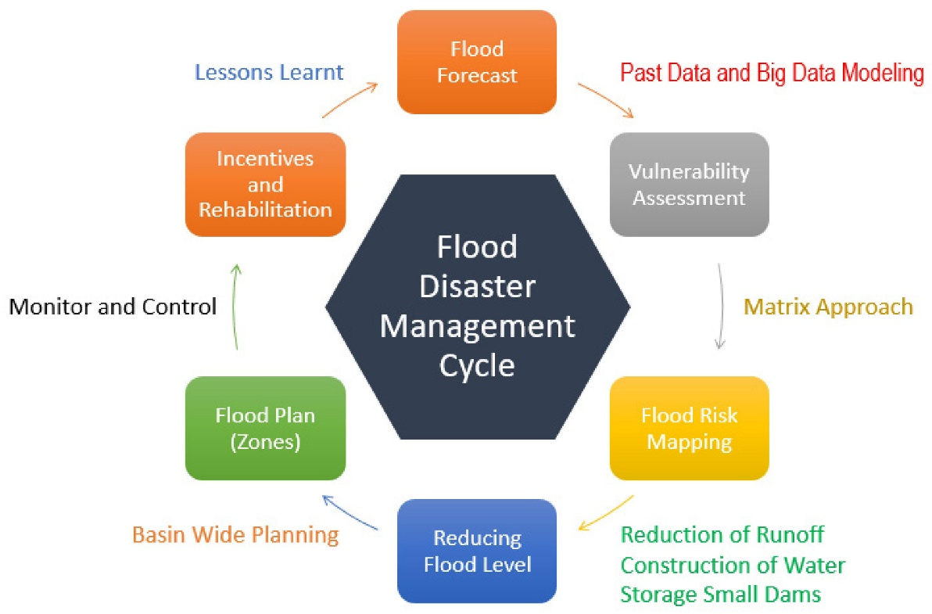Flood control refers to all methods used to reduce or prevent the detrimental effects of flood waters . Some of the common techniques used for flood control are installation of rock berms, rock rip-raps, sandbags, maintaining normal slopes with vegetation or application of soil cements on steeper slopes and construction or expansion of drainage channels. Other methods include levees, dikes, dams, retention or detention basins. After the Katrina Disaster that happened in 2005, some areas prefer not to have levees as flood controls. Communities preferred improvement of drainage structures with detention basins near the sites.Positive effects of flooding.

**Positive Effects of flooding**

1. Flooding makes the land fertile

Perhaps, one of the most recognized benefits of flooding is that it makes the land fertile. As the water eventually recedes, it leaves behind fine sand, clay, silt and organic matter. This is why floodplains are one of the most fertile agricultural areas in the world. Ancient Egyptians understood this principle well as they farmed along the Nile. They thus called episodic flooding of the Nile as ‘The Gift of the Nile’.

1. Flooding adds nutrients to the sea

Likewise, small seasonal floods contribute nutrients to the sea. Small organisms like plankton feed on them and multiply. In this way, they support higher aquatic food webs including humans.

1. Dislodges accumulated debris

Also, the force of rushing floodwater can dislodge materials that block rivers and estuaries. Debris like branches, logs, boulders often hinders the movement of water in rivers. Sometimes, they can inhibit the flow of water altogether leading to droughts downstream.

**Negative effects of flooding**

We have to keep in mind that flooding is a natural process in the environment. It becomes a problem when people live/build too close to floodplains. Or when they modify the land so much that it can no longer absorb water.

1. Floods damage built infrastructure

Without a doubt, rushing water is very powerful. Whether it comes from a river overflow or a dam break, floods can destroy everything along their way.

They inundate houses, buildings, bridges and damage property. They can also initiate fires leading to explosions. Very often, they also damage drainage systems especially sewage networks. Waste matter thus spills leading to pollution. Or they contaminate water bodies making the water unfit for drinking.

As an example, the 2010 flood event in Pakistan damaged the property of 20 million people. And 10 million had no access to safe drinking water.

1. Flooding leads to economic losses

Such destruction obviously leads to drastic economic losses. Hurricane Katrina remains the most expensive flood in US history, totalling US $81 billion.

As floods destroy transportation and communication networks, people cannot work. They also wipe out agricultural land or transmit diseases to farm animals. In 2019, two storms flooded Malawi, Mozambique and Zimbabwe destroying 780,000 hectares of agricultural land.

Regions that depend on coastal tourism and associated businesses suffer significantly as well. Floods can severely affect their properties or even discourage tourists from visiting such places. While such businesses often have insurance cover to build back, it is yet another battle to get hold of that money.

1. Loss of lives and social disruption

When caught unaware, floods can kill thousands to millions of people at one go. This is especially real in Asia where people are mostly farmers who live close to floodplains. In fact, one of the worst floods ever occurred in China in 1931 on the Yangtze River. Torrential rain flooded a 1300 km2 area and killed around 4 million people directly and indirectly.

Moreover, floods can injure a number of people or lead to mental health issues. Very often, they also cause disease outbreaks such as diarrhoea and gastroenteritis as water becomes polluted.

And on top of everything, as they destroy crops and farms, they disrupt the livelihoods of many communities.

4 Extreme floods cause erosion

As it is, extreme flooding events can wipe away significant amounts of sediment. This can eventually lead to bank erosion, collapse or even landslides where the terrain is steep.

For example, monsoon flooding causes severe erosion in the state of Assam, India. The width of the Brahmaputra River has increased by 15 km because of bank erosion!

1. Flooding causes algal blooms

Unfortunately, floods can also stimulate algal blooms in the sea, lakes and rivers. The load of nutrient especially phosphorous and nitrogen stimulate algae to grow and multiply rapidly. Eventually, they cover the surface of the water preventing oxygen from penetrating inside. As a result, organisms that live inside die.